Given a positive integer n, generate an n x n matrix filled with elements from 1 to n2 in spiral order.

**Example 1:**

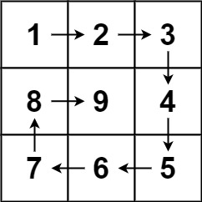

**Input:** n = 3

**Output:** [[1,2,3],[8,9,4],[7,6,5]]

**Example 2:**

**Input:** n = 1

**Output:** [[1]]

**Constraints:**

* 1 <= n <= 20